**Vision Document for “**e-shopper**”**

**Team members:**

**Daniel Zuemui -109376**

**Dawit Mebrahtu -986826**

**Henok Solomon -986506**

**Redae Mengsteab -109371**

**1. Introduction**

This project provides the web application for online shopping. The purpose of this project is to provide an easy online shopping facilities and easy selling facility to the merchants of all categories.

The main reason behind developing the project is the problems which were faced by the customers because of shortage of time and convenience.

Some of the advantages are:

1. **Convenience**: In comparison to store with fixed hours, online shopping venues are available to shoppers any time of the day or night. This is especially useful for moms with small children, people who are homebound, people who work days, and in times of inclement weather.
2. **Price comparisons**: When you visit a store, you most likely settle for whatever price the vendor has placed on an item. Not so with online shopping-you compare prices from hundreds of different vendors.
3. **Discounts and notifications:** Online stores want to keep you as a customer, so they may [offer deep discounts, rewards, and cash back](https://www.lifewire.com/best-rewards-and-cash-back-shopping-sites-4147155) in your pocket if you sign up for their newsletters. They, they can keep you apprised of upcoming sales you wouldn't have otherwise known about.
4. **Infinite choice**: Shelf space in a store is limited, which means that your variety of goods is limited. Not so with an online store—the choices are overwhelmingly abundant. If you don't see what you want at one store online, you can move on to the next one. As the consumer, you have the power to do that.
5. **Easy access to consumer reviews**: It's easy to access consumer reviews for pretty much any product you can think of online, which makes for informed purchases. Not sure you're up to buying something? Look at the reviews from other consumers, and you'll be better able to make an informed decision.
6. **No pressure sales**: We've all experienced awkward overtures by eager salespeople. You don't have to put up with that online at all.

**2. Positioning**

**2.1 Problem Statement**

Customer can browse through the product catalog and add the items to shopping cart. He can proceed to check out as long as his shopping cart is not empty.

Customer will require to login to the system when he proceed to check out or he can create an account if he not yet have one.

|  |  |
| --- | --- |
| The problem of | *managing the Compro schedule and allowing students to*  *register for classes* |
| Affects | *administrators, faculty, and students* |
| the impact of which is | *scheduling is complex, must be manually maintained, and*  *changed frequently* |
| a successful solution would be | *one tool which builds a Compro schedule that integrates the*  *business rules for faculty availability and courses needed by*  *students per entry. This tool will provide a Database and a*  *user interface that is easy to use for faculty, staff, and*  *students.* |

**2.2 Product Position Statement**

*[Provide an overall statement summarizing, at the highest level, the unique position the product intends to*

*fill in the marketplace. The following format may be used:]*

|  |  |
| --- | --- |
| For | *[target customer]* |
| Who | *[statement of the need or opportunity]* |
| The (product name) | *is a [product category]* |
| That | *[statement of key benefit; that is, the compelling reason to buy]* |
| Unlike | *[primary competitive alternative]* |
| Our product | *[statement of primary differentiation]* |

*[A product position statement communicates the intent of the application and the importance of the project*

*to all concerned personnel.]*

**3. Stakeholder Descriptions**

**3.1 Stakeholder Summary**

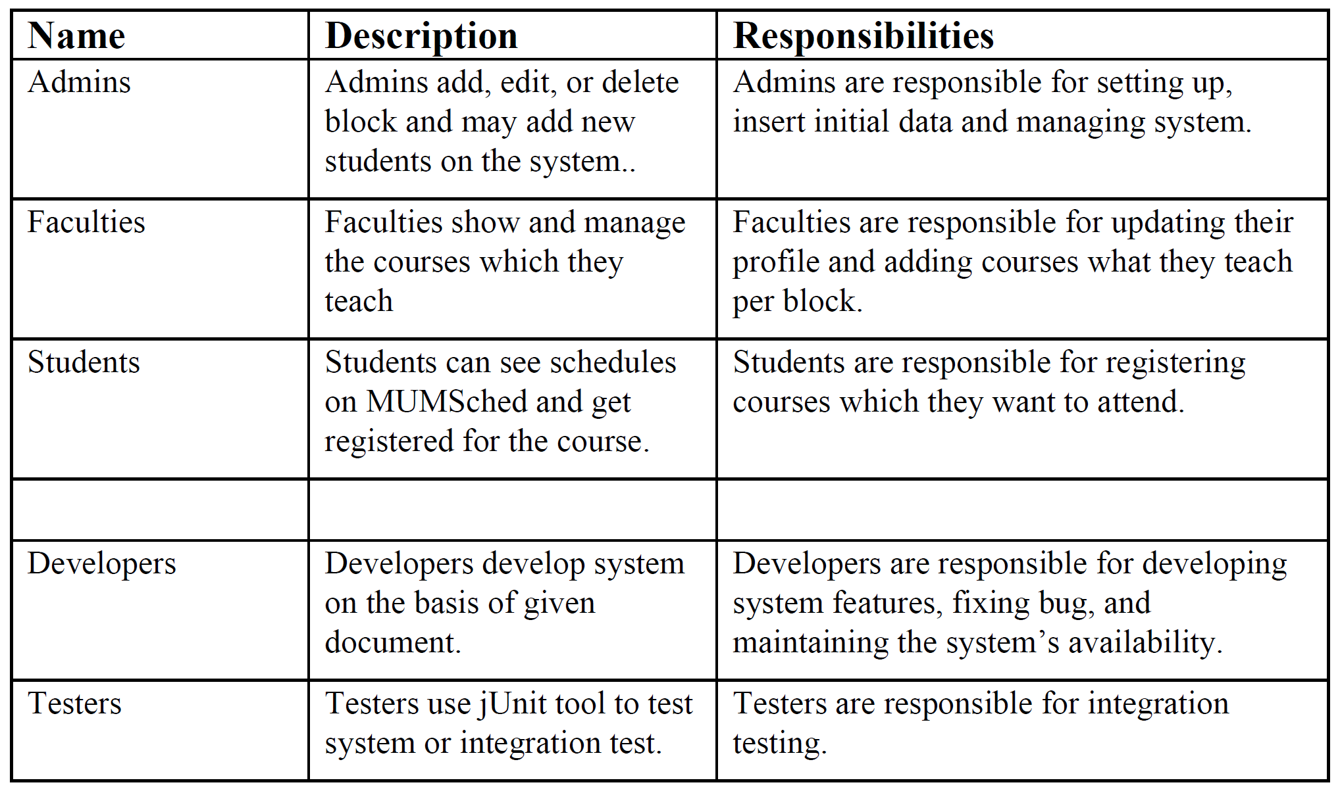

**3.2 User Environment**

*[Detail the working environment of the target user. Here are some suggestions:*

*Number of people involved in completing the task? Is this changing?*

*How long is a task cycle? Amount of time spent in each activity? Is this changing?*

*Any unique environmental constraints: mobile, outdoors, in-flight, and so on?*

*Which system platforms are in use today? Future platforms?*

*What other applications are in use? Does your application need to integrate with them?*

*This is where extracts from the Business Model could be included to outline the task and roles involved,*

*and so on.]*

**4. Product Overview**

**4.1 Product Perspective**

*[This subsection of the* ***Vision*** *document puts the product in perspective to other related products and the*

*user’s environment. If the product is independent and totally self-contained, state it here. If the product is a*

*component of a larger system, then this subsection needs to relate how these systems interact and needs to*

*identify the relevant interfaces between the systems. One easy way to display the major components of the*

*larger system, interconnections, and external interfaces is with a block diagram.]*

**4.2 Assumptions and Dependencies**

*[List each factor that affects the features stated in the* ***Vision*** *document. List assumptions that, if changed,*

*will alter the* ***Vision*** *document. For example, an assumption may state that a specific operating system will*

*be available for the hardware designated for the software product. If the operating system is not available,*

*the* ***Vision*** *document will need to change.]*

**4.3 Needs and Features**

*[Avoid design. Keep feature descriptions at a general level. Focus on capabilities needed and why (not*

*how) they should be implemented.]*

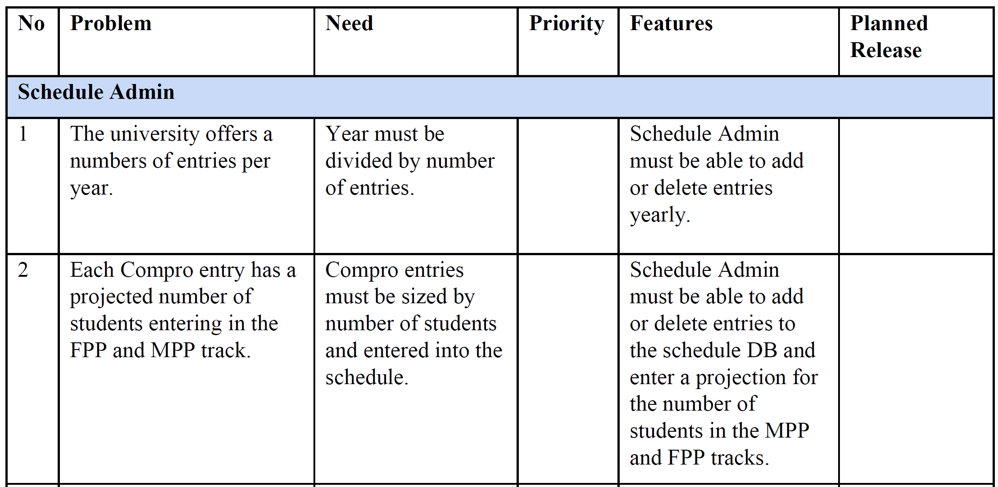

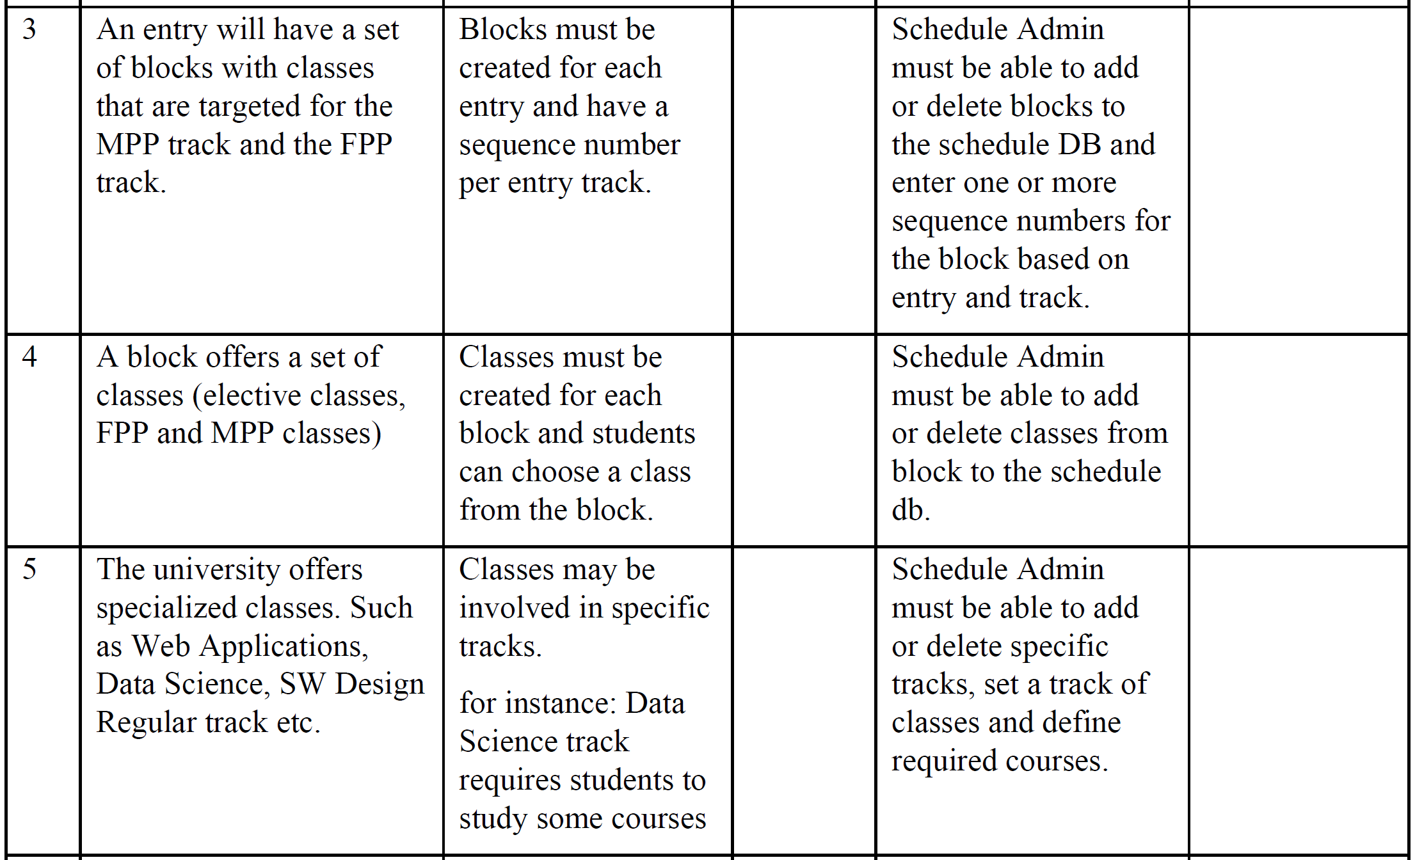

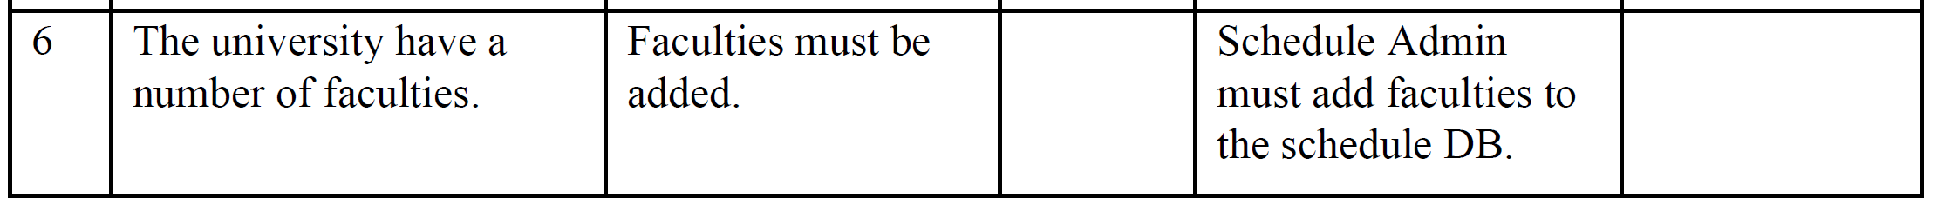

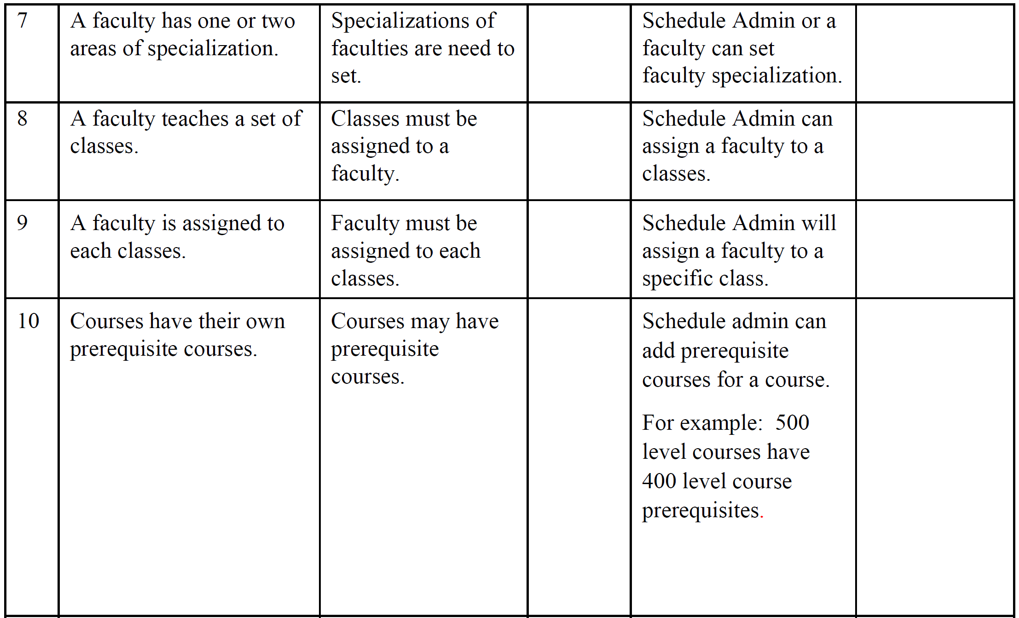

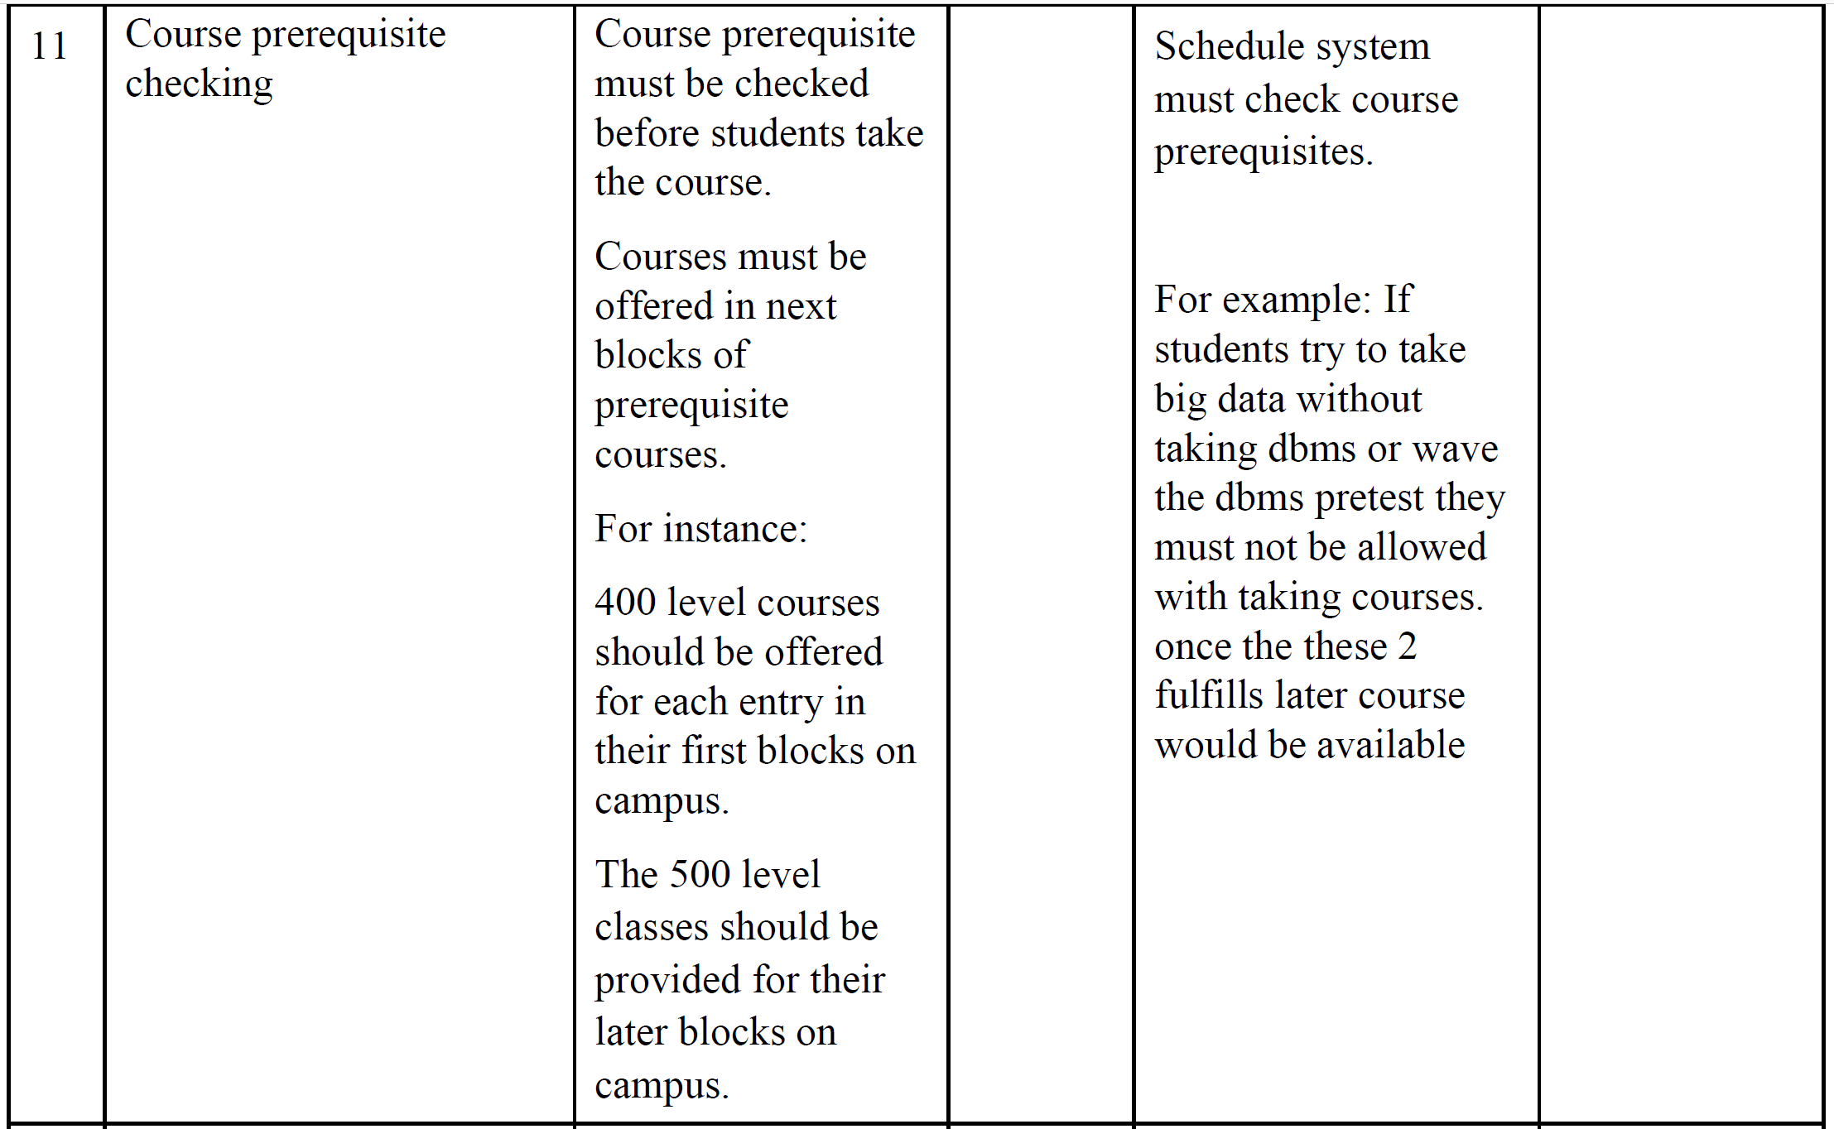

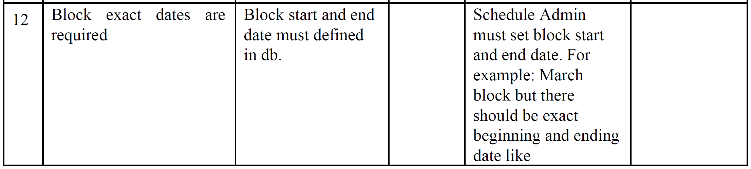

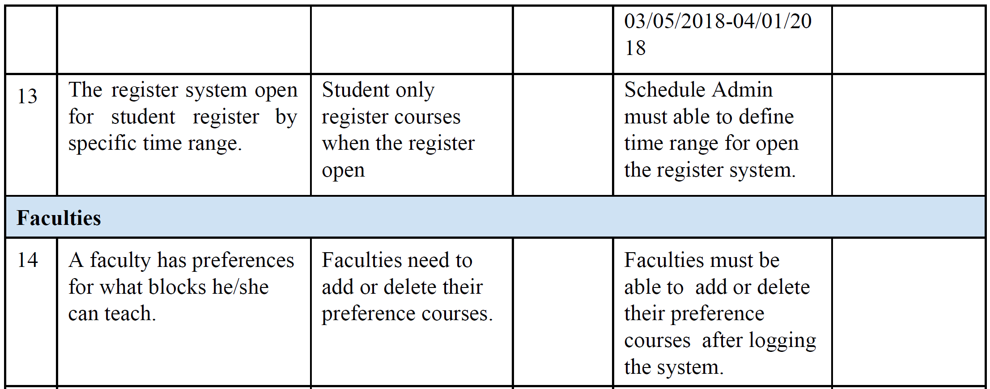

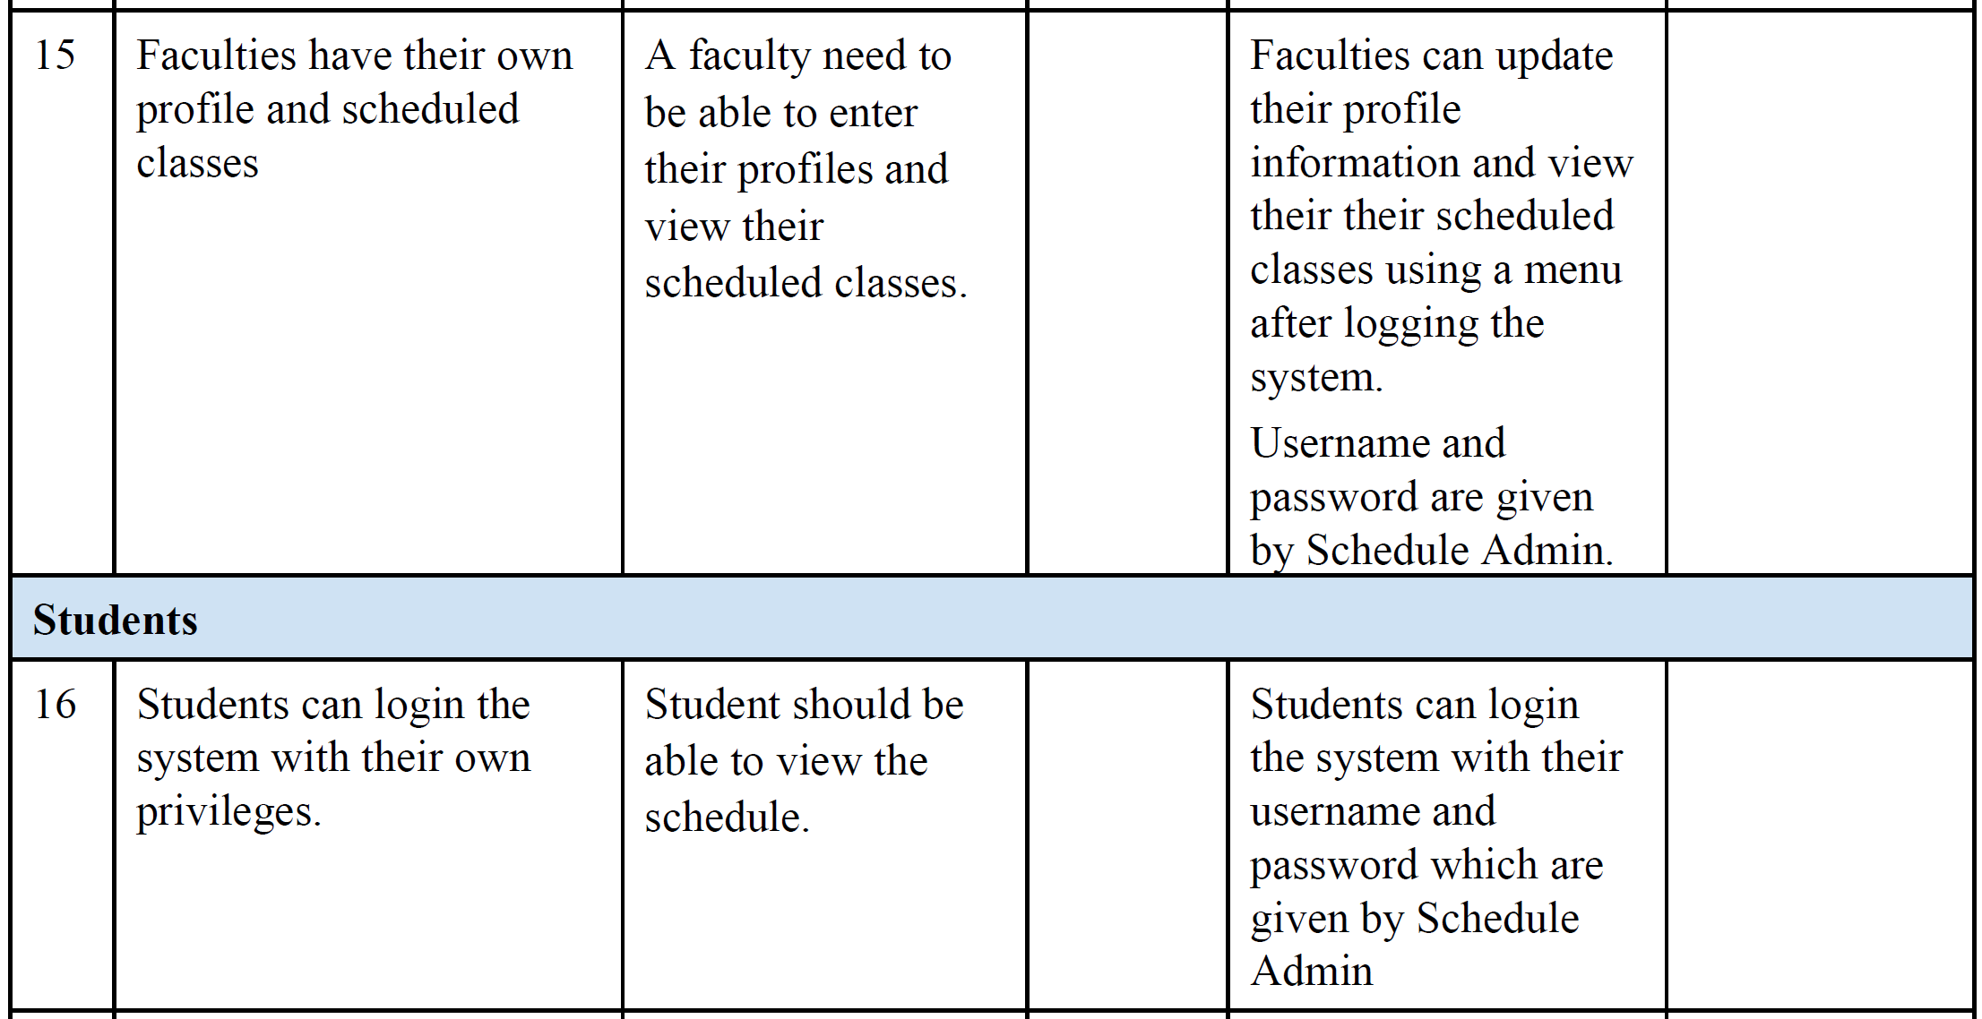

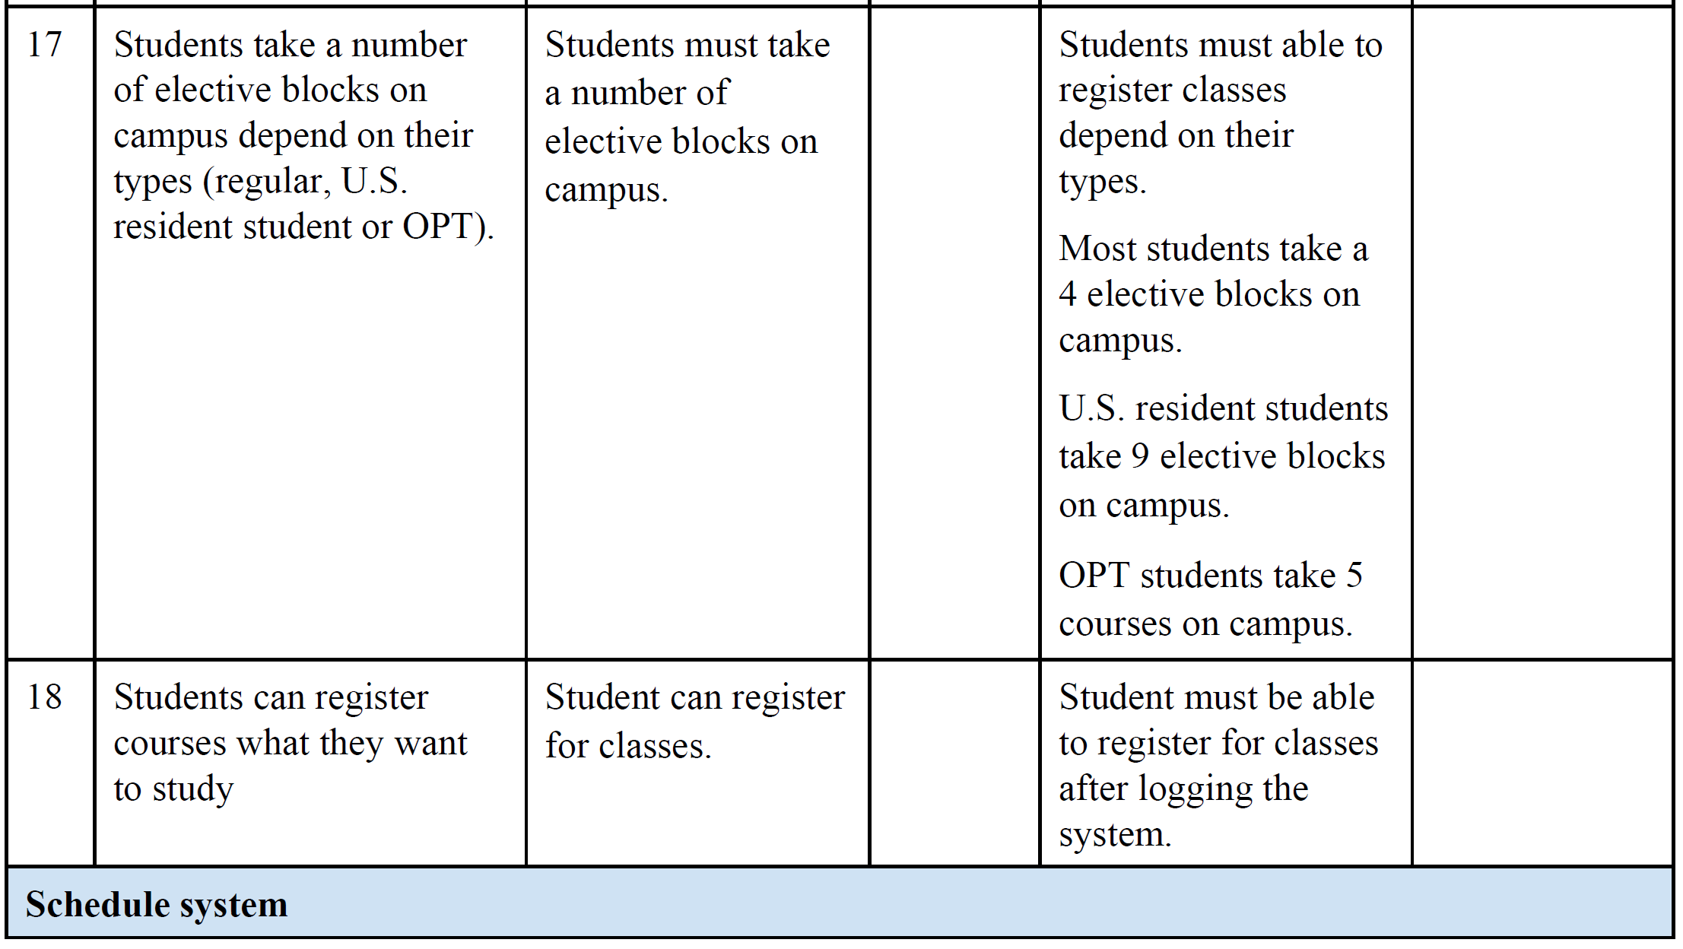

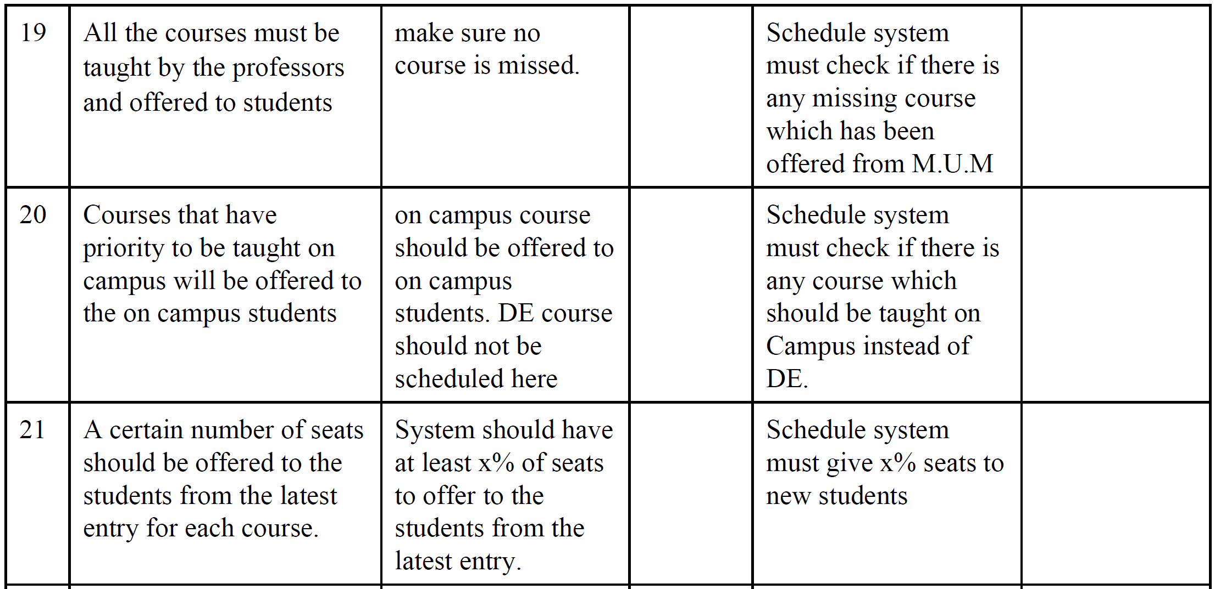

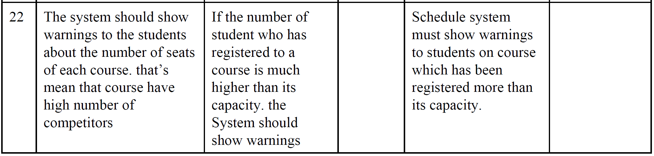

**4.4 Alternatives and Competition**

*[Identify alternatives the stakeholder perceives as available. These can include buying a competitor’s*

*product, building a homegrown solution, or simply maintaining the status quo. List any known competitive*

*choices that exist or may become available. Include the major strengths and weaknesses of each competitor*

*as perceived by the stakeholder or end user.]*

**5. Other Product Requirements**

*[At a high level, list applicable standards, hardware, or platform requirements; performance requirements;*

*and environmental requirements.*

*Define the quality ranges for performance, robustness, fault tolerance, usability, and similar*

*characteristics that are not captured in the Feature Set.*

*Note any design constraints, external constraints, or other dependencies.*

*Define any specific documentation requirements, including user manuals, online help, installation,*

*labeling, and packaging requirements.*

*Define the priority of these other product requirements. Include, if useful, attributes such as stability,*

*benefit, effort, and risk.]*